ABOUT PROFILE SEARCH ON HOME PAGE
we would like to divide the seach in two
(EXAMPLE: SELECTING "PLAYER" POPS UP THE PLAYER'S FORM)
"Search for player's profile"
"Search for coach's profile"
Main requests for players:
- MALE/FEMALE
- POSITION
- PROFESSIONAL/SEMI-PRO/AMATEUR
(please pull from Techical Data/ 2) Current Division/
Professional will be pulled from lines A,B; Semi-pro from B,C,D, Amateur D,E)
- HEIGHT
- AGE
- CITIZENSHIP
- CURRENT RESIDENCE
- NATIONAL TEAM PLAYER YES/NO
- CONTRACT EXPIRATION
Main requests for coaches:
- MALE/FEMALE
- PROFESIONAL/SEMI-PRO/AMATEUR
- CITIZENSHIP
- CURRENT RESIDENCE
- LANGUAGES
- NATIONAL TEAM COACH YES/NO
- CONTRACT EXPIRATION
Of course, we would like that the reserch works
even if some of the fields haven't been selected
(I mean, if someone is searching for a player
can select for example only the “position“ field
and will receive all the possible results just for this request)
===============================================================

Add your player's profile

Personal data

(For Personal data all are mandatory fields except the photo – The photo will be requested via mail to be added within a certain time)

1)Name:
2) Surname:
3) Username:
4) Password:
5) Sex:
6) Date of birth: (This will be age related) please check the last page
7) Male /Female
8) Height- please check the last page
9) Weight please check the last page
10) Citizenship::
11) Current residence:
* 12) Insert your photo:
===========
Technical data

1) Choose your position:

- Goalkeeper
- Left wing
- Left back
- Central back
- Right back
- Right wing
- Pivote

2) Current division

A) National Top Division (Pro)
B) National Lower Division (Pro/Semi-Pro)
C) Regional Division (Semi-Pro)
D) Provincial Division (Semi-Pro/Amateur)
E) Amateur

3) Current and Previous Clubs
- Gmail attachement style
(new option pops up once the former has been filled)
4 things are meant here:
a) Name of the club
b) Country (for this we'd like just a country flag by the club's name)
c) Start (month and year) d) End (month and year)
4) Career achievements
(here below will be an open field for writing)
- Availability
a) from ( your contract expiration month and year)
mm | yyyy

b)
now available
6) Are you / have you been / a National team player
Yes | No

If Yes
6a) National team catergory (player could choose more options)
Senior
Junior
Youth

6b) National Team represented
List of Countries
(here we would like a flag by country's name)
6c) Remarkable participations in events organised by IHF, Continental Federations AHF/CAHB/EHF/OHF/PATHF, Students or Multi-Sport Games Committee
( there will be also an open field for writing)

===============================================================
Private Area

1) Email-address:

2) Phone number:

3) Insert your video link:

If the player is represented by someone

4) Manager's contact:

4a) Manger's Email-address:

4b) Manger's Phone number:
==========================================================

Regarding Height and Weight + Age

All are divided in 2 parts (except Weight)

1) Height
1a) On the Home page:
160 or less, 161-165, 166-170, 171-175, 176-180, 181-185, 186-190, 191-195, 196-200, 201-205 and 206- more)

1b) In the Personal Data ( of course here the player will choose his/her real height which starts from):
160 cm or less, 161, 162,163 ...and so on till 216 or more)

2) Weight
2a) On the Home page
WILL NOT BE PRESENT THIS INFO
2b) In the Personal Data ( here the player will choose his/her real weight)
50 kg or less, 51,52, 53 ...so on till 125, 126 or more)

3) Age
3a) on the Home page:
under 18, 18-23, 24-29, 30-33, 34 on
3b) this will be the date of birth related

Below we are sending the details about the structure of the form.
When the user submits the form will be displayed a thanks message with in a pop up mode. After the registration, the player/ coach will receive an email confirmation (we will provide you the layout). To activate the profile, the user has to access through a particular link.

PERSONAL DATA

First Name //only charachters no numbers – use a specific regEX - Mandatory
Last name//only charachters no number – use a specific regEX - Mandatory
Password: (free choice) Mandatory
Password confirmation
Sex: Male/ Female Mandatory
Date of birth: dd/mm/yyyy - linked to "Age" field <15, 15, 16, .. 43, 43> Mandatory
Citizenship (select menu with related country flag) Mandatory
Current residence (select menu with related country flag) Mandatory
Mother tongue (drop down menu selection with NO flags)Mandatory
Other languages (drop down menu selection NO flags)Mandatory
Photo – not mandatory to put the picture

TECHNICAL DATA

Position: Goalkeeper/ Left Wing/ Left Back/ Center Back/ Right Back/ Right Wing/ Pivot Mandatory
Height (in "cm"): <drop down menu list starting from 150cm till 220cm > Mandatory
Weight (in "kg"): <drop down menu list starting from 45kg-140kg> Mandatory
Hand: Left/ Right/BothMandatory
Current League: 1st Division/ 2nd Division/ 3rd Division/ 4th Division /5th Division Mandatory (preceded by the flag of the country)
– the field will be named League (as it is now) and should match the division declared in availabity fields (see it below) – the last team the player played for or still plays for
Sports Status
- Professional Athlete
- Semi-professional Athlete
- Amateur Athlete
National Team (NO Flags – just a drop down menu with country options)
- Senior
- Junior
- Youth
- none
(the highest chosen level will be shown in the layout – in case of „none“ will be shown „n/a“)
A PROFILE EXAMPLE

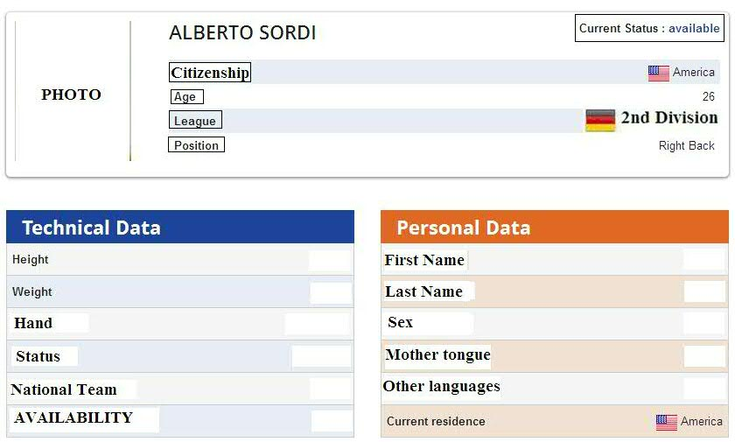

Current status: Under contract/ Available (should be put in the top right corner)

* This information here below should be put in the Technical Data box under the „voice“ AVAILABILITY
(or the word „Immediate“ or the „date of the expiration of the current contract“) 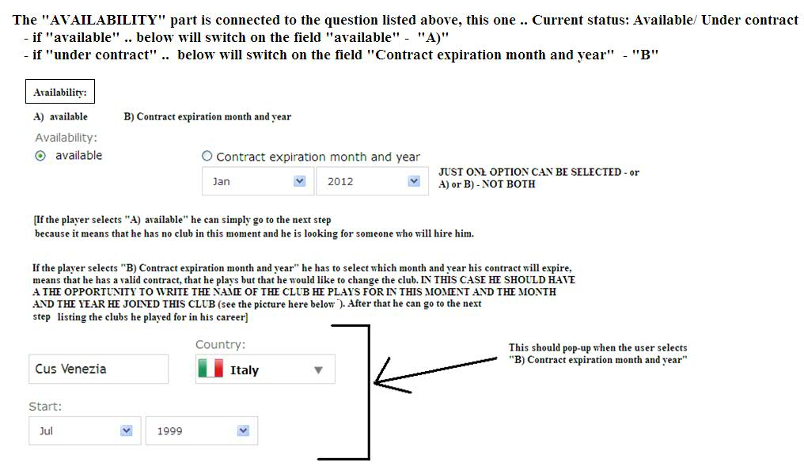
(*this is the current League info as well)

Clubs: when a player registers more than one team he played for,
the form should automatically create a new field
(the first team the player played for in his career should be at the bottom of the
list .. as shown in the image below)

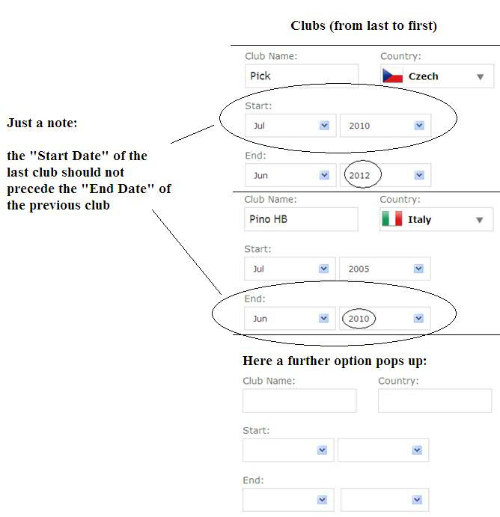
- manually enter the name of the team
- Under country please apply the Division options (mentioned here above)
Please NO COUNTRY NAMES just the FLAG and the divison (from 1st to 5th)
- and the player should choose only months and years as in the image here below (better if numbers the months as well so from 01 till 12)

Result should look like

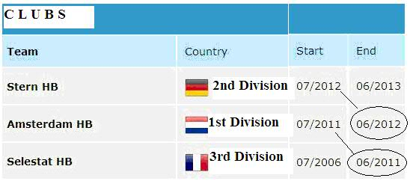

Career Achievements: this is an open field where the player can write manually his/her career results and remarkable events

PRIVATE AREA

Personal or agent's email:
Personal or agent's phone number:
Video link:

Hello

It is necessary to highlight that while adding clubs the buttons RESET and NEXT PAGE are getting too low on the div.

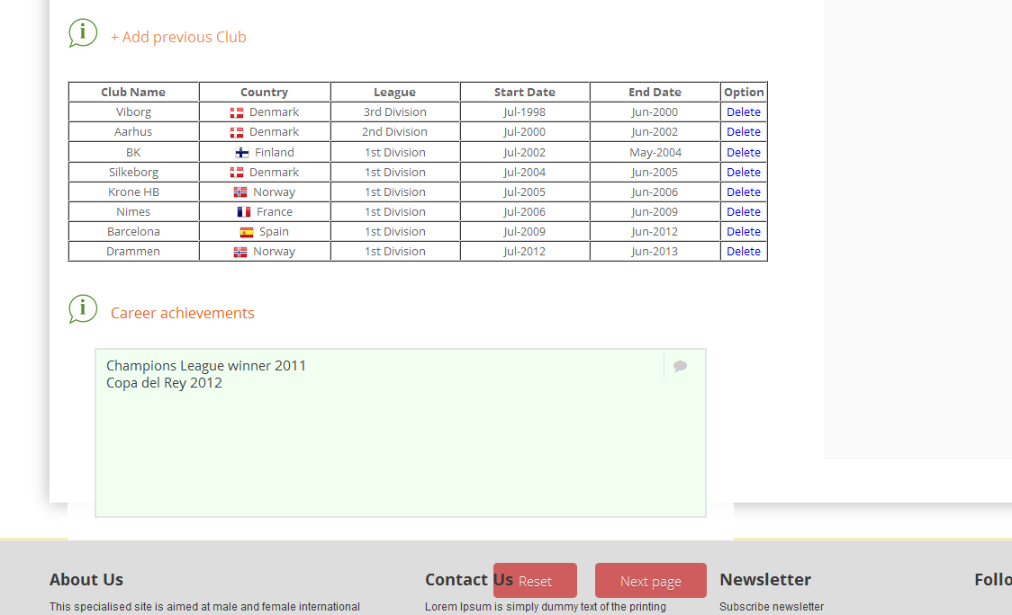

There are problems when using NUMBERS in the club name field. If we put numbers the following alert pops up.

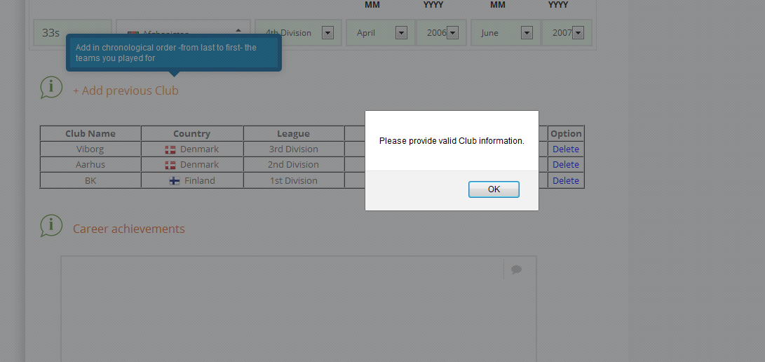

When filling the Achievements field there are always 2 dots following the last word.
Please fix this bug.

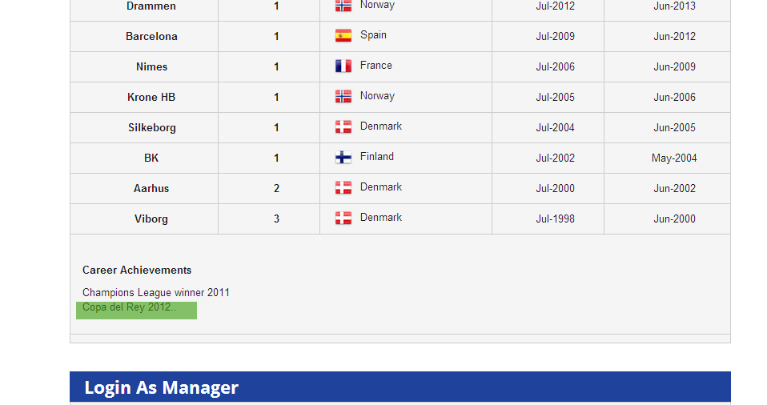

HANDBALL-PROFILE

Playing positions

Goalkeeper

Left Wing Pivot Right Wing

Left Back Right Back

Centre Back

=============================================================

Full name
Date and place of birth
Citizenship
Playing position
Left-hander / Right-hander
Height
Weight
Current Team
Contract Expiration Date
Clubs
National Team appearances
Career highlights

- Poi l’idea ausiliaria sarebbe quella di istituire l’Handball-Profile Award
[un All-star team scelto annualmente da una selezione di profili che han avuto successo durante la stagione]

